Alimgozha Adil

Lab 1

1. The Human Resources (HR) department needs data including id, full name, hiring date and salaries of all employees.

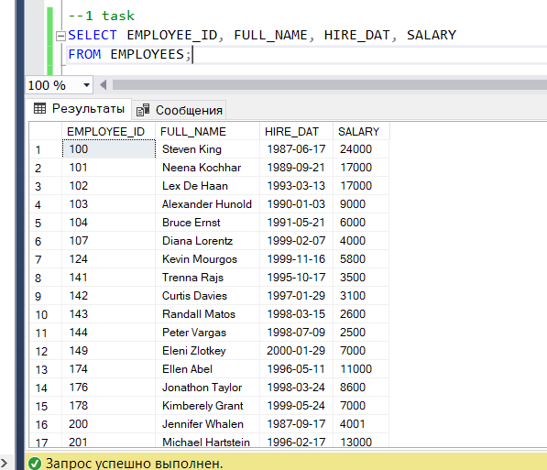

1. Write a query to display id, full names, email, annual salaries of all employees.

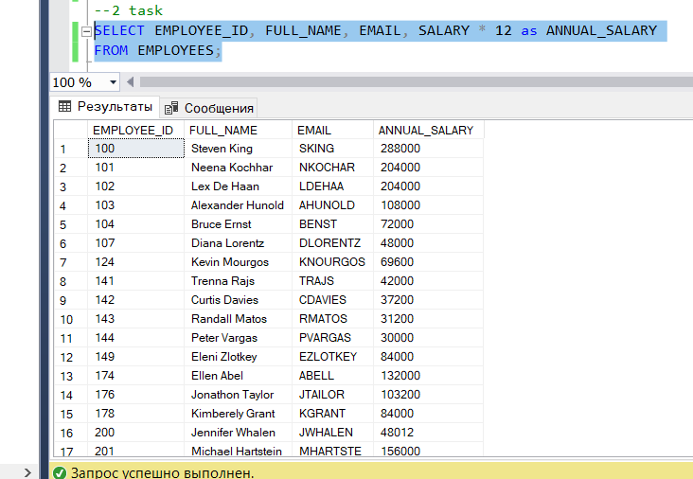

1. The Human Resources (HR) department requests data for all unique jobs from the EMPLOYEES table. Job IDs should not be repeated in the output.

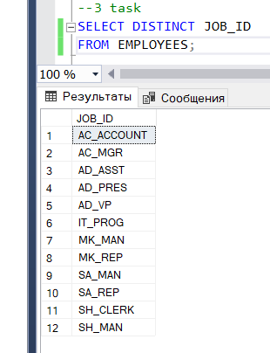

1. Due to funding problems, the HR department needs a report that provides all the information about the programmers whose salaries are over 5000.

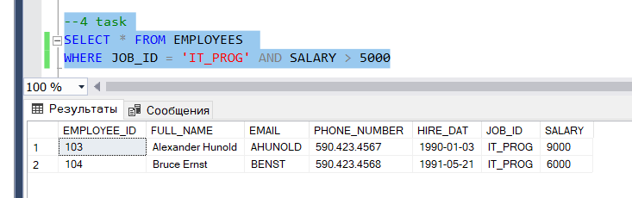

1. Generate a report to display the id, full name, and job title of all employees whose salaries range from 4000 to 7000 (including left and right boundaries). (USE BETWEEN!)

1. The HR department needs data on high-paid and low-paid employees. Write a query to display the full name, and salaries of all employees whose salaries are outside the range from 3000 to 9000 (USE BETWEEN!).

1. Write a query to display id, last names, first names, annual salaries of those employees whose annual salaries are below 50000.

1. Write a query to display id, full name, salaries of those employees whose salaries are in the range from 4000 to 7000 (excluding left and right boundaries). Explain the difference between this task and task #5.

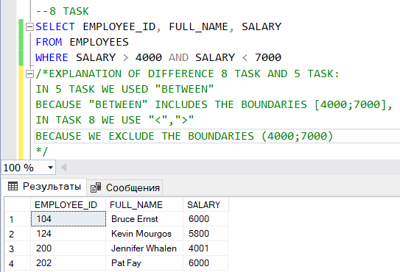

1. Write a query to display id, full name, salaries, job title from the list of id «144, 102, 200, 205»

1. Write a query to display id, full name, salaries, job title not from the list of id «144, 102, 200, 205».

1. Write a query to display id, full name, salaries of those employees whose second letter of surname is the letter ‘a’.

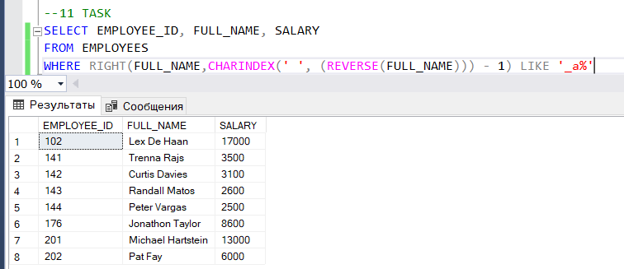

1. Write a query to display all the names of employees where the third letter of name is ‘a’.

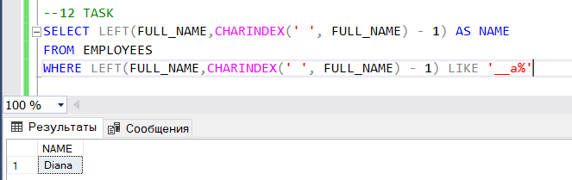

1. Write a query to display id, full name, email, salaries of those employees whose FIRST LETTER of NAME + last name = EMAIL of each employee. Example: full_name = Steven King, email = SKING. Here name is Steven → First Letter is S, last name = King. FIRST LETTER of NAME + last name is S + King = SKing = SKING. Consider upper and lower cases to be the same (S = s).

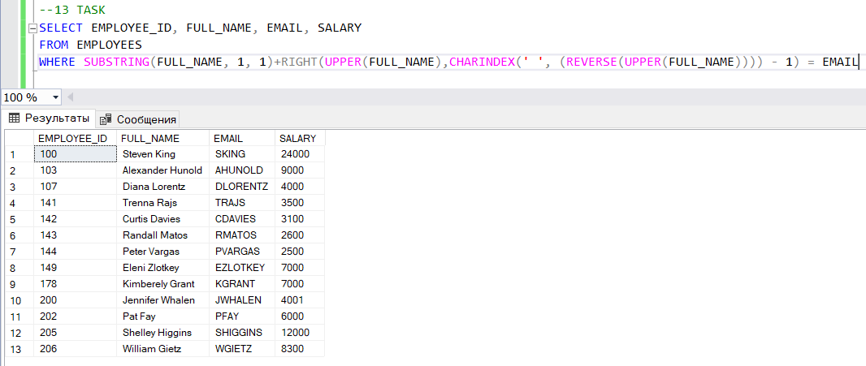

1. Write a query to display id, full name, email, salaries of all employees, sorting their salaries in ascending order then by hire date in descending order.

1. Write a query to display id, full name, salaries of all employees, sorting their id in descending order

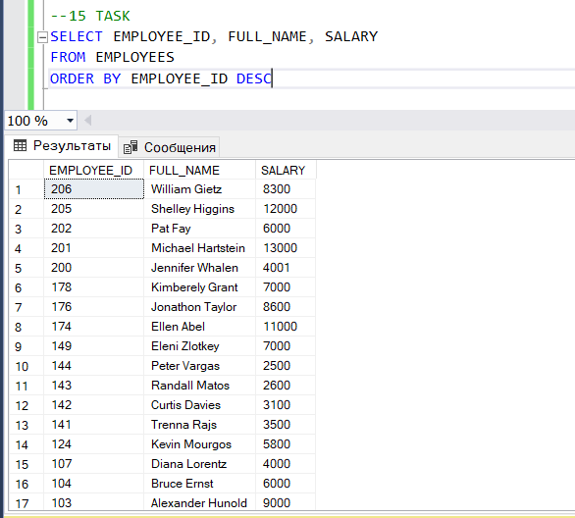

1. Write a query to display the average, maximum, minimum and the sum of all programmers' salaries.

1. Write a query to display the whole employee info whose first figure of phone number if the same as last figure the same phone number. Example: 650.121.2996. Here ‘6’ is the first figure as well as the last one.

1. Write a query to display the number of unique professions.

1. Sum the salaries in the EMPLOYEES table for each job title.

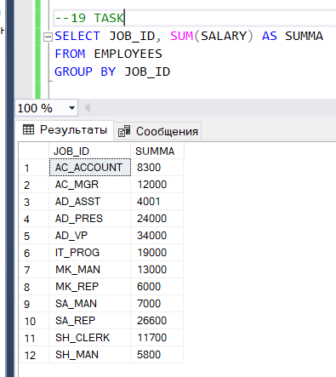

1. Find the average salaries in the EMPLOYEES table for each job title.

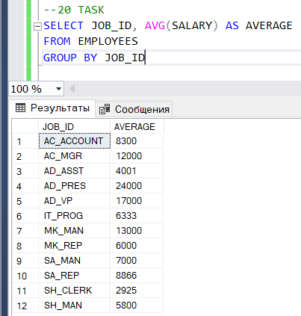

1. Find the maximum salaries in the EMPLOYEES table for each job title that exceed 10,000 and sort them in descending order.

1. Find the maximum average salary for each job title.

1. Receive a report for each employee in the following form: “full_name” earns “salary” per month, but wants “triple salary”. Name the column Dream Salaries.

1. Write a query to display the full name and the number of letters in the full name of employees (a space counts as one character).

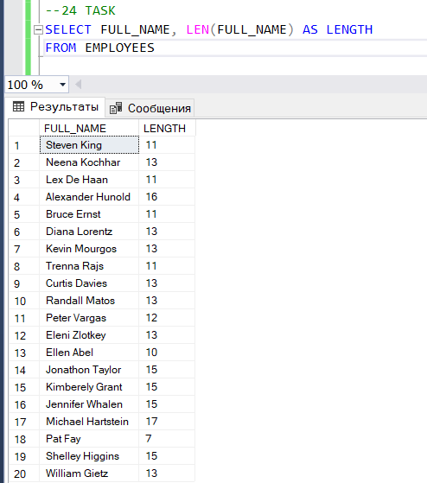

1. Write a query to display only first name from a column full_name. Example: FULL_NAME: ‘Steven King’. The output must be 1 column named ‘first_name’ with the data ‘Steven’.

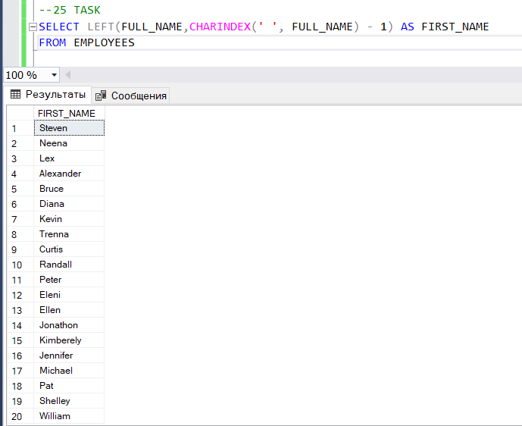

1. Write a query to display the first three letters in the first names of employees.

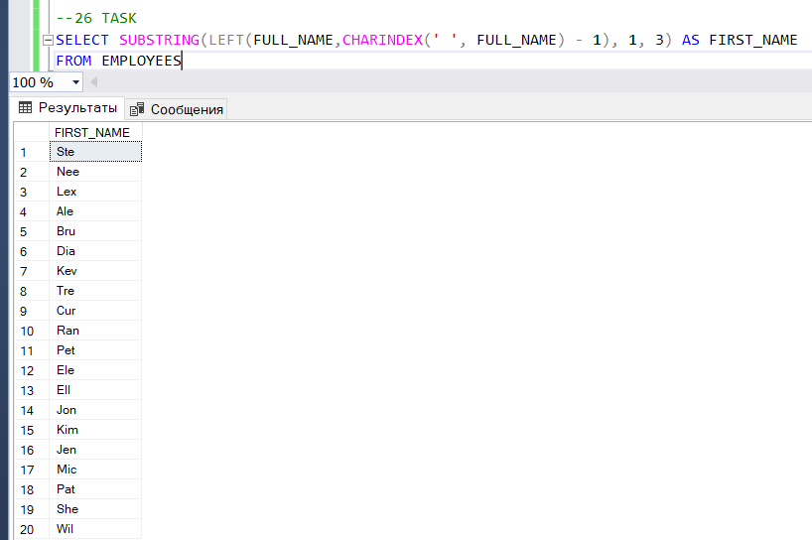

1. Write a query to display the letters in the full names of employees in reverse order.

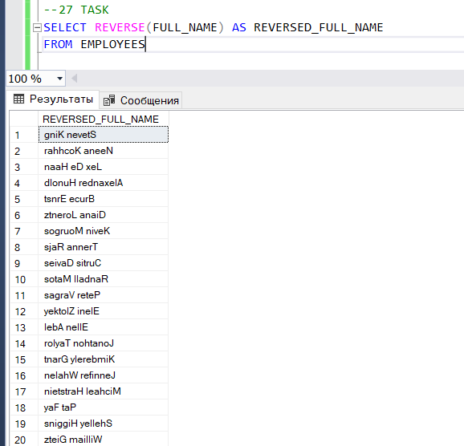

1. Replace "en" characters in the full_names of employees with "yu" characters.

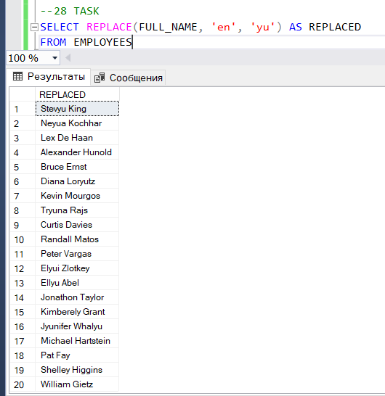

1. Convert all letters in the full names of employees to uppercase.

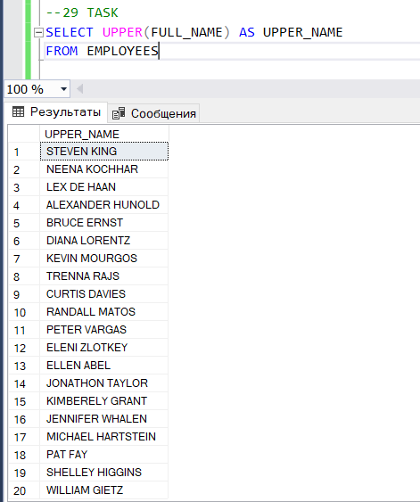

1. Your query and explain it ( code comments). The query must be interesting. It is not sufficient just to write easy UPDATE, DROP TABLE, DELETE with no arguments. Apply creativity.

